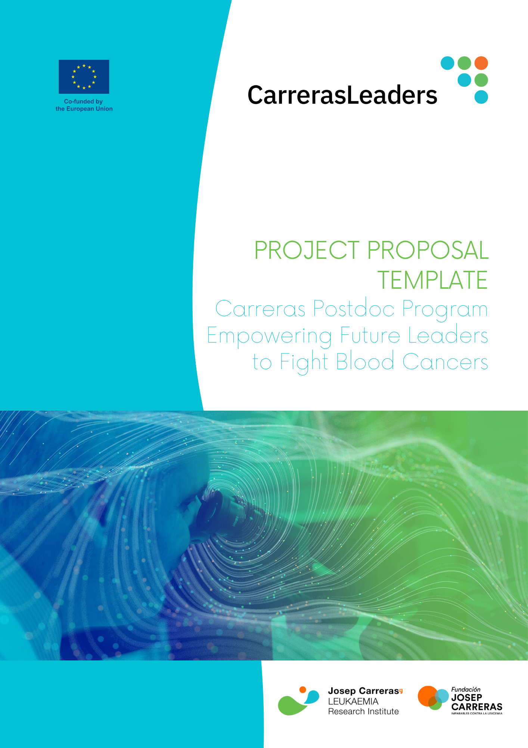

Project Proposal template

General Information on structure and length:
This project proposal will be evaluated with up to 20 points at the remote evaluation stage. The maximum length of the project proposal should not exceed 10-pages including figures, tables, etc. The proposal should include the following sections (more info below):

1. Cover Page (1 page) with abstract (300 words) – start page of 10-page limit
2. Excellence of research project (up to 10 points)
Background
Rationale, Motivation, Objectives
Work plan and Timeline
3. Quality of the proposed secondment (up to 5 points, 0.5 page)
4. Impact (up to 5 points, recommended to keep below 2 pages)
Dissemination, communication, and exploitation of results
Two-way transfer of knowledge
Gender diversity in research
5. Bibliography (recommended 1 page max.)
6. Ethics self-assessment (1 page) – end page of 10-page limit

Please use this formatting: Arial 11, A4 page size, 2 cm margins, numbered pages.
Please convert your final document in PDF format for submission.
Please make sure you have deleted the guidance notes (provided in green boxes) before submission.

1. COVER PAGE

Candidate full name
Project Acronym
Project title
IJC Principal Supervisor:
Secondment Host (= Co-supervisor)*
Free keywords (Max 5)

*not mandatory but highly valued

Abstract (300 words)

In the abstract you should provide a short summary of the proposal with clear understanding of the objectives of the proposal and the methodology to achieve them.
Keywords and areas of expertise will be used to find matching evaluators. For areas of expertise please see Annex III – List of Areas of Expertise in Application Guide.

2. EXCELLENCE OF RESEARCH PROJECT (10 POINTS)

Background
Rationale, Motivation and Objectives
Work plan including a timeline

This section will be evaluated with up to 10 points.
Background: Please provide necessary background information.
Rationale, Motivation, Objectives: In a concise and clear manner explain the rationale of your project and the gap of knowledge that you wish to address. Outline objectives and specific goals.
Work plan including timeline: In this section, please provide a detailed plan of your research. Describe the methods and techniques you plan to use to conduct your research. Consider structuring in work packages and to define milestones and deliverables. Outline the expected timeline in a table or a flowchart to show that your project is well-planned and realistic within 3-years.

3. QUALITY OF THE PROPOSED SECONDMENT PLAN (5 POINTS)

This section will be evaluated with up to 5 points. We recommend aiming for 0.5 page.
A major goal of CarrerasLeaders is to promote collaboration between countries, and partners from the non-academic sector. As such it is highly recommended to pre-define a several month-long secondment during which you will work at a partner that makes most sense for your proposed research. The researcher hosting you during your secondment will become your co-supervisor. In case you are selected, they will need to provide a letter of commitment. Many partners have already expressed their interest to collaborate in CarrerasLeaders projects and are listed on the CarrerasLeaders website.

4. IMPACT (5 POINTS)

Dissemination, communication, and exploitation of results
Two-way transfer of knowledge
Gender diversity in research

This section will be evaluated with up to 5 points. We recommend aiming for a maximum of 2 pages.
- Dissemination, communication, and exploitation of results: Please explain how you plan to disseminate, communicate and exploit your research results.
- Two-way transfer of knowledge: Please explain the two-way transfer of the knowledge between you as a fellow and your research group. Which will you learn and what knowledge and skills will you bring.
- Gender diversity in research: Describe how the sex, gender and other diversity aspects are considered in your research and innovation. Sex, gender, and diversity analysis refers to biological characteristics and social/cultural factors. If you do not consider such a gender dimension to be relevant in your project, please provide a justification. This question relates to the content of the planned research and innovation activities, and not to gender balance in the teams in charge of carrying out the project.

5. BIBLIOGRAPHY (1 PAGE MAX)

6. ETHICS SELF-ASSESSMENT (1 PAGE)

1. HUMAN EMBRYONIC STEM CELLS AND HUMAN EMBRYOS | YES/NO
Does this activity involve Human Embryonic Stem Cells (hESCs)?
Does this activity involve the use of human embryos?
2. HUMANS
Does this activity involve human participants?
Does this activity involve interventions (physical also including imaging technology, behavioural treatments, etc.) on the study participants?
Does this activity involve conducting a clinical study as defined by the Clinical Trial Regulation (EU 536/2014)? (Using pharmaceuticals, biologicals, radiopharmaceuticals, or advanced therapy medicinal products)
3. HUMAN CELLS / TISSUES (NOT COVERED BY SECTION 1)
Does this activity involve the use of human cells or tissues?
4. PERSONAL DATA
Does this activity involve processing of personal data?
Does this activity involve further processing of previously collected personal data (including use of pre-existing datasets or sources, merging existing datasets)?
Is it planned to export personal data from the EU to non-EU countries? Specify the type of personal data and countries involved
Is it planned to import personal data from non-EU countries into the EU or from a non-EU country to another non-EU country? Specify the type of personal data and countries involved
Does this activity involve the processing of personal data related to criminal convictions or offences?
5. ANIMALS
Does this activity involve animals?
6. NON-EU COUNTRIES
Will some of the activities be carried out in non-EU countries?
Does this activity involve low and/or lower middle-income countries, (if yes, detail the benefit- sharing actions planned in the self-assessment)
Could the situation in the country put the individuals taking part in the activity at risk?
7. ENVIRONMENT, HEALTH AND SAFTEY
Does this activity involve the use of substances or processes that may cause harm to the environment, to animals or plants. (during the implementation of the activity or further to the use of the results, as a possible impact)?
Does this activity deal with endangered fauna and/or flora / protected areas?
Does this activity involve the use of substances or processes that may cause harm to humans, including those performing the activity. (during the implementation of the activity or further to the use of the results, as a possible impact)?
8. ARTIFICIAL INTELLIGENCE
Does this activity involve the development, deployment and/or use of Artificial Intelligence? (if yes, detail in the self-assessment whether that could raise ethical concerns related to human rights and valuesand detail how this will be addressed).
9. OTHER ETHICS ISSUES
Are there any other ethics issues that should be taken into consideration?

Please provide additional brief information on the points that you indicated YES in the table. Please limit yourself to 150 words. In case your project is selected, you will need to pass a full ethical review.
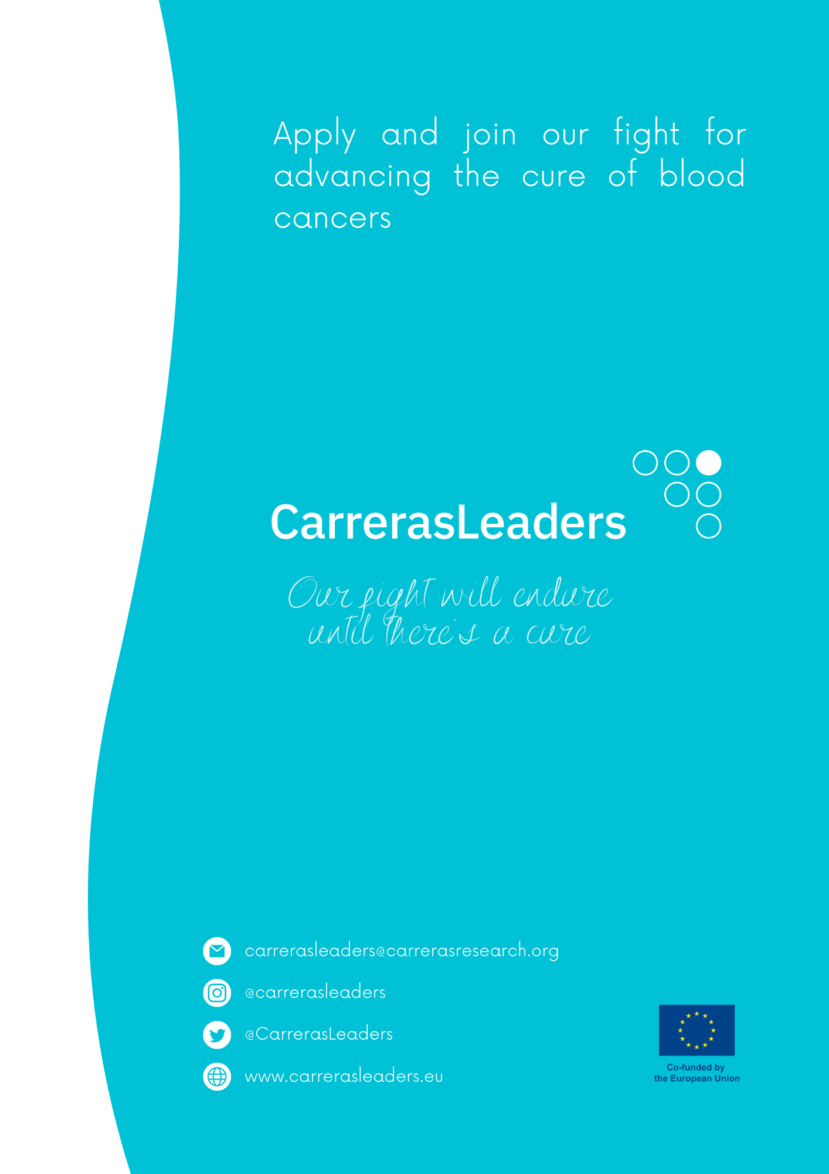

Gendered innovation 2: How inclusive analysis contributes to research and innovation (europa.eu), https://research-and-innovation.ec.europa.eu/knowledge-publications-tools-and-data/publications/all-publications/gendered-innovation-2-how-inclusive-analysis-contributes-research-and-innovation_en.

